EXPERIMENT 3 — STEP-WISE

PART A: LOAD DATASET

Step 1: Import the Global Superstore Dataset
We opened Power BI Desktop and imported the Global Superstore Dataset.xlsx file using Home → Get Data → Excel Workbook. The Orders, Returns, and People worksheets were selected and loaded into Power BI.
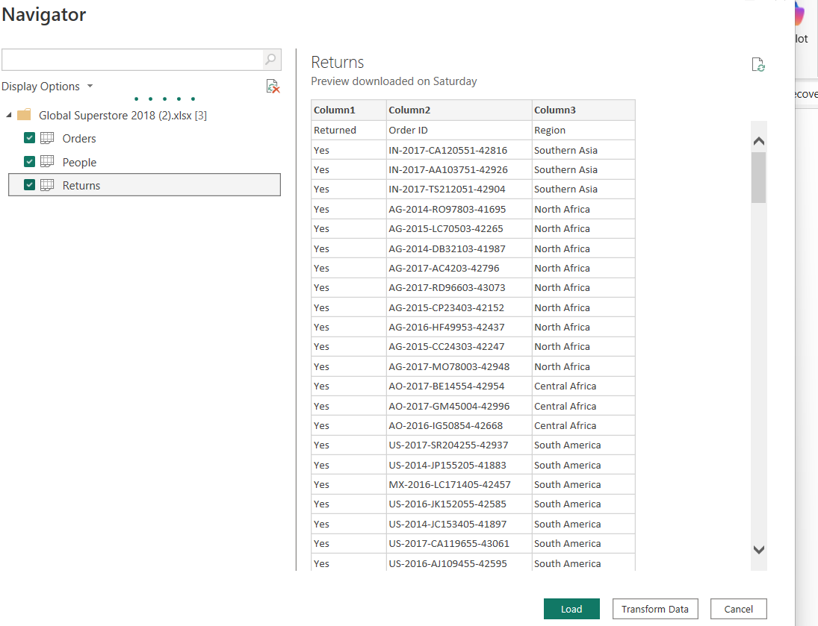

PART B: IDENTIFY FACT AND DIMENSION DATA

Step 2: Analyze the Orders Table
We examined the Orders table and identified the fields that represent measurable business activities, such as Sales, Profit, Quantity, and Discount. We also identified descriptive fields such as customer, product, region, and date information.
These fields were then separated conceptually into Fact and Dimension data.
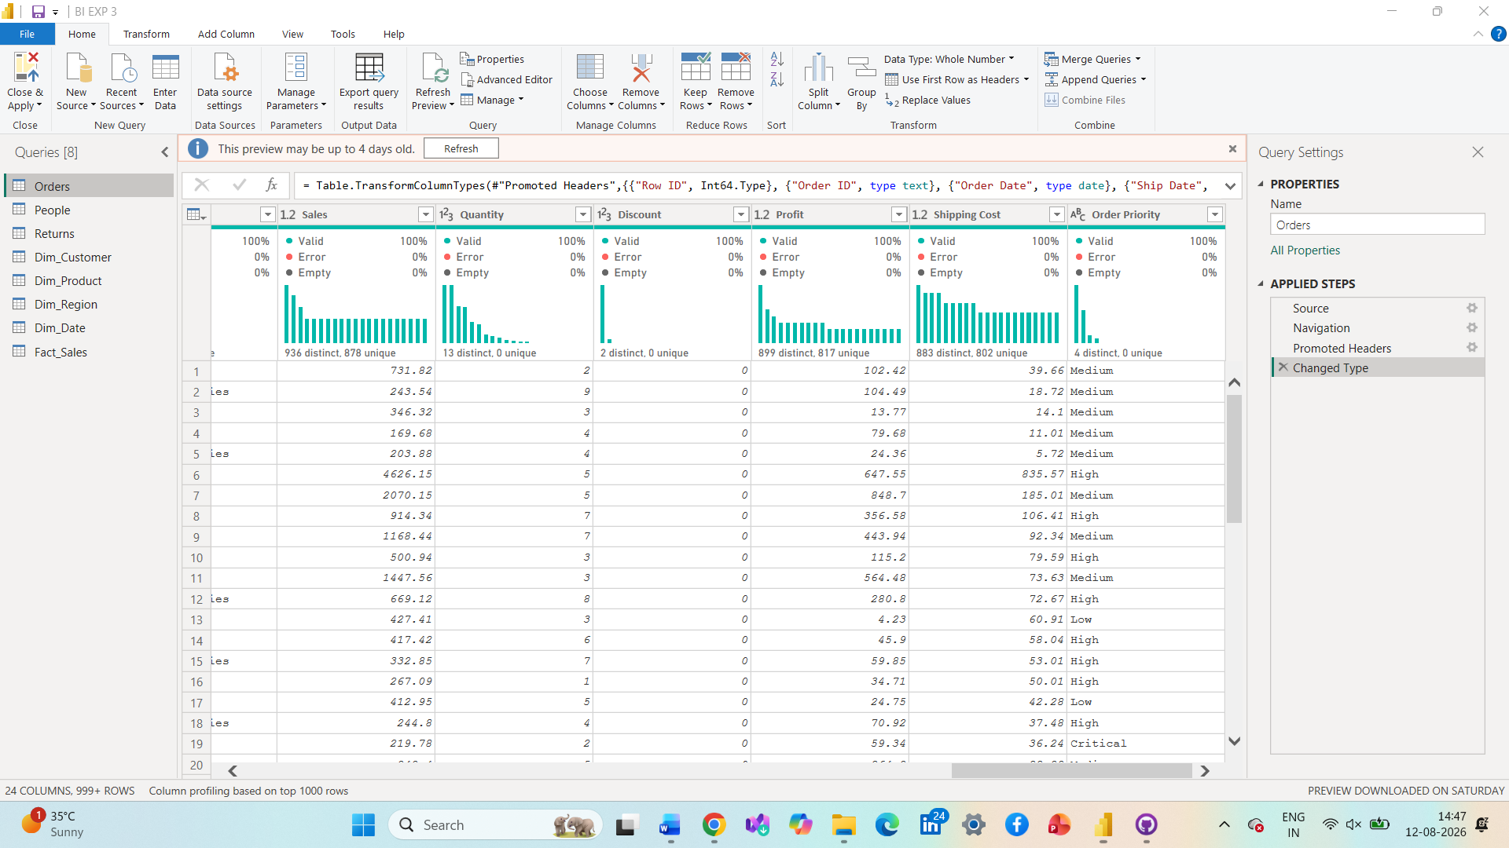

PART C: CREATE DIMENSION TABLES

Step 3: Create the Dimension Tables
Using Power Query, we created the required dimension tables:
- Dim_Customer — Customer ID, Customer Name, Segment
- Dim_Product — Product ID, Product Name, Category, Sub-Category
- Dim_Region — Region, Country, State, City
- Dim_Date — Order Date, Year, Quarter, Month
Duplicate records were removed from the dimension tables to ensure that the dimension keys remained unique.
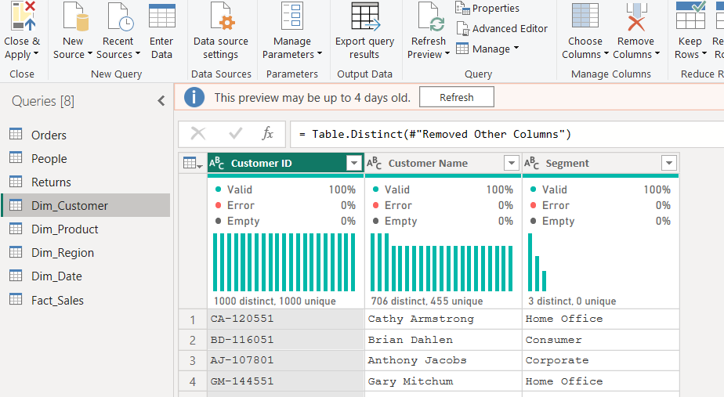
PART D: CREATE FACT TABLE

Step 4: Create Fact_Sales
We created the Fact_Sales table containing the main transactional information:
- Order ID
- Customer ID
- Product ID
- Region
- Order Date
- Sales
- Quantity
- Profit
- Discount
The required key columns were checked so that relationships could be created with the dimension tables.
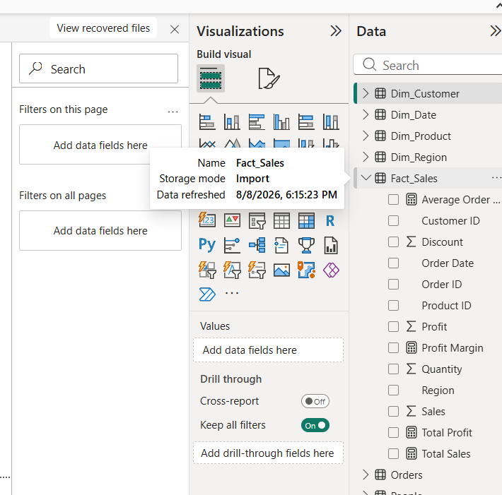

PART E: BUILD THE STAR SCHEMA

Step 5: Create Relationships
We opened Model View and connected Fact_Sales with the dimension tables using their corresponding key fields. The relationships were configured as Many-to-One, with the fact table on the many side and dimension tables on the one side.
The tables were arranged around Fact_Sales to form the Star Schema structure.
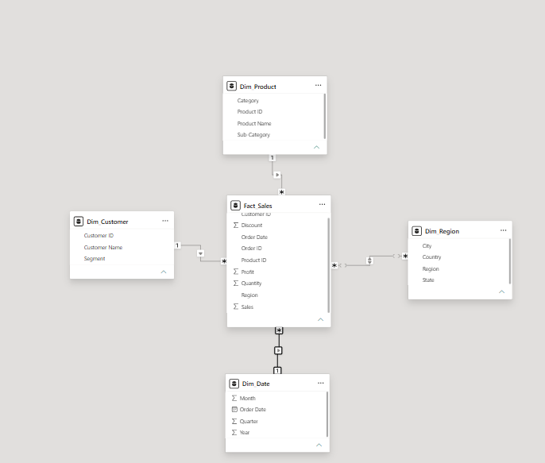
PART F: VALIDATE THE MODEL

Step 6: Create Measures and Reports
We created DAX measures for:
- Total Sales
- Total Profit
- Profit Margin
- Average Order Value
We then created visualizations such as Sales by Category, Profit by Region, and Sales Trend by Year to check whether the dimensions correctly filtered the Fact_Sales data.
